LECTURE 4 ON EXPLOITATION

Questions of this week:
- What do political economists mean by "exploitation"? How is exploitation in capitalism different from exploitation in other forms of society?

- What is absolute and what is relative surplus-value? Provide some historical examples for each using the sources at your disposal (iPhone case, Amazon article, Taylorism etc) and explain how they help increase the rate of exploitation.
- How does the film Modern Times represent the phenomenon of exploitation?

Last week we discussed the two formulas that characterize our lives under capitalism.

i) C-M-C: characterizes the general condition of market dependence we all live in. To satisfy any of our needs, we are compelled to sell our capacity to work (labor power) on the market. If we want something, we have to pay for it. For example, do you want a sandwich? Then go and get a job! It does not matter what specific job you do (Marx calls it abstract labor). We have normalized the fact that to eat, we have to work for a wage… But this is the very particular to our capitalist society.

ii) M-C-M’ (where M’ > M): is the formula that expresses the logic of capitalism that is embodied by the capitalist class. It expresses the driver that is the DNA of our system: production for profit. Money (as the expression of value) is not just a means to an end (consumption) but becomes an END in itself. Capitalism is indeed an economic system that is characterized by economic growth: which presupposes the constant accumulation of capital (meaning the constant investment of money to get more money).

We thus were able to understand the definition of Capitalism:

Capitalism is a peculiar socio-economic system in which employers (or capitalists) use privately owned means of production (Pillar 2) to hire wage labor (Pillar 1) to produce commodities for the purpose of making profits. [accumulation for the sake of accumulation]

We were left with the question: where does M’ (profits), the driver of capitalism, come from?

It is in answering this question that it becomes obvious how “Capital,” in its most apparent form of money and wealth, can exist because of a more foundational condition: a specific social relation of production between two distinct classes. This social relation takes the form of capitalist exploitation.
- The basis for Profits: Exploitation
[Question 1: What do political economists mean by "exploitation"? How is exploitation in capitalism different from exploitation in other forms of society?]
Exploitation in political economy has a technical meaning, thus a different meaning from the common usage of the term. Exploitation is commonly used to mean the action of treating someone unfairly in order to take advantage of them. But, in political economy, it has a more precise meaning. It means that, in class societies, the producers are expropriated from what they produce. For example, under feudalism, the lord takes a part of the total wheat that the serf has grown, or the slave-owner keeps the cotton that a slave picks.
Capitalist Exploitation: Capitalist exploitation is, however, unique. Capitalist exploitation is not visible in the sphere of the market where the worker signs a work contract.
It appears that workers are paid “a fair day’s wage for a fair day’s work.” Capitalist exploitation is deceptive because it is implicit.
To see capitalist exploitation, you have to investigate the sphere of production (as Marx puts it: “the hidden abode of production”), where the worker is put to work, and the capitalist consumes the special commodity--labor power--that he has purchased on the market. In line with the work contract, capitalists pay workers a wage. However, in exchanging their capacity to work for a wage workers confer the use of their labor to the capitalist for the entire workday. The extra value (surplus value) that the worker creates during the workday (beyond the value of the wage) is appropriated by the capitalist. In other words, the surplus value produced by workers accrues to the capitalist and becomes profit.
Thus, if you understand exploitation, you see that it does not matter how much you are paid but how much more value you produce with respect to how much you are paid! Very well-paid workers are also exploited. Think about a software engineer for Apple: they get paid $200,000 a year but contribute millions a year to the company's revenue.

Let’s investigate this process more closely:
- The Capitalist’s Side
1. A Capitalist appears as a buyer: buys the commodity of labor-power (capacity to work) from the “free worker” and other ingredients of production with its initial amount of Money (M)

2. A capitalist puts his commodities to work in the industrial process. The worker actively exerts her muscle energy and works and produces commodities that have a value that is greater than the cost of her wage (C’>C). These commodities embody new surplus value.

[IMPORTANT: in this reasoning, we assume that commodities embody value: this value is measured by the amount of socially necessary labor time to produce it. That is, how much time it takes in a given society to produce a certain commodity: the longer the time, the greater the value. We can simplify and say that this value corresponds to the “exchange value”: that is, the price. Any commodity also has a use-value: what we use this commodity for. Eg: a toothpaste takes 5 hours to make in the USA and has a price of 5 dollars. This means that we exchange it (or buy it) for 5 dollars (exchange value). Its use value corresponds to the fact that we use it to brush our teeth to make them cleaner. NOTE: the value form is not a universal attribute of goods; rather it is an attribute specific to comedies under capitalism since it is the result of the specific relations of production in our society. If you want to learn more on this point you can read chapter 1 of Capital or come to my office and I will explain it!]

“In order to extract value out of the consumption of a commodity, our friend the money-owner must be lucky enough to find within the sphere of circulation, on the market, a commodity whose use-value possesses the peculiar property of being a source of value, whose actual consumption, therefore is itself an objectification of labor, hence a creation of value. The possessor of money does find such a special commodity on the market: the capacity for labor, in other words labor-power.” (Marx, Capital Vol.1)
[Important: it is not the commodity, labor power, that produces value! Commodities contain value but cannot create new value. It is living labor (the amount of actual labor time) that is the source of value!]
3. A capitalist turns to the market as a seller: once sold, his commodities are turned into money that is greater than the amount they invested in the first place. This means that the capitalist is able to realize his surplus value or, otherwise said, make a profit (M’>M). This new capital is used to purchase new labor power and new machines. Thus, capital accumulation continues.

- The Worker’s Side

As a worker, you search for a job, you sign a contract, and you are paid a wage. This means that you get paid the full price for the commodity you are selling, i.e., your labor power (or your capacity to work). Indeed, no one is “ripping you off”: it is an exchange of “equivalents.” The money you get corresponds to how much your commodity -- labor power -- is valued on the market in that particular historical moment (for example, now that the labor market is “strong,” and there are fewer workers to hire, the market wage is going up). It thus appears as if you are getting paid for your actual work. However, in reality, you are getting paid for the price (or exchange value) of your commodity labor power (capacity to work). You actually work a lot more, and produce a surplus…but this is hidden and only visible if you explore what actually happens in the process of production.

NOTE: Your wage is not the price of your living labor. Rather, it is the price of your labor power, that is, the commodity that you are selling on the market. This difference is the KEY to understanding the source of profit! Indeed, once you clock-in you do not have control over the use of your work hours, and you do not own the product of your labor.

Quote of Marx to discuss in class: [On the idea that Exploitation is “hidden’ and it is lawful]
“The use- value of labor-power, in other words labor, belongs just as little to its seller, as the use-value of oil after it has been sold belongs to the dealer who has sold it. The owner of the money has paid the value of a day’s labor-power; he therefore has the use of it for a day, a day’s labor belongs to him. On the one hand the daily sustenance of labor-power costs only half a day’s labor, while on the other hand the very same labor-power can remain effective, can work, during a whole day, and consequently the value which its use during one day creates is double what he pays for that use; this circumstance is a piece of good luck for the buyer, but by no means an injustice towards the seller.” Capital, Chapter 7, p.301

IMPORTANT: The capitalist pays you for the price of your labor-power, not for your actual work or the value of the goods you produce.
Thus, when you work, you are repaying your wage (the cost of your labor power) the rest of the time you work for free!

[Example: if hired by Starbucks, you are paid $100 a day, but you sell $1000 worth of coffee in an hour, then that is a surplus of $900 an hour (not counting the expenditure on machines). During their eight-hour-shift, workers at a Kellogg's factory produce cereal and snacks that are worth thousands of dollars each day but actually get paid only 120 dollars a day].

[Note: The price of your labor power (your wage level) is both socially and historically determined. (for example, it depends on the historical moment; region of the world, bargaining power of workers; economic policies, etc.). It is normally set at an amount that pays for the subsistence and reproduction of labor...but nowadays can also be lower!
“The value of labor-power is determined by the value of the means of subsistence habitually required by the average worker.”

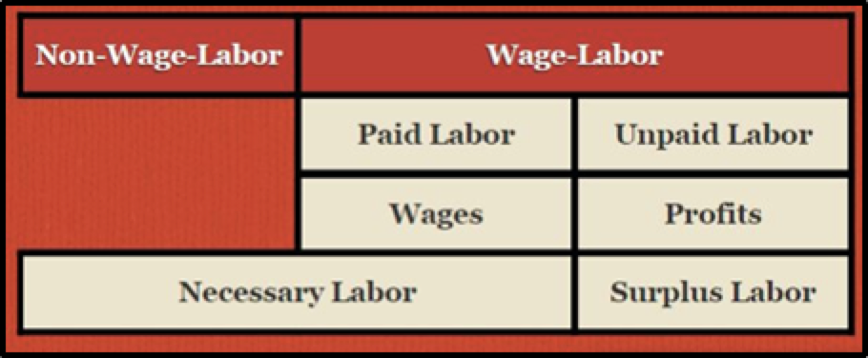

Capitalism does not only rely on unpaid wage labor but also on NON-WAGE LABOR---(household work--- or State welfare, State schooling etc) OUTSIDE OF THE WORKPLACE! These are all costs for the reproduction of the working class that the capitalist is not required to pay for.
“The working class doesn’t only work in its workplace. A woman worker also sleeps in her home, her children play in the public park and go to the local school, and sometimes she asks her retired mother to help out with the cooking. In other words, the major functions of reproducing the working class take place outside the workplace.” (Thier, p.78)

II. Increasing the Rate of Exploitation

Rate of profit: is measured as the ratio between the capitalist’s surplus and how much the capitalist pays in his investment. S (surplus) divided by V (variable capital: how much he spends on wages) and C (constant capital: how much he spends on machines, technology, etc.). Rate of Profit (r) = S/ (C+V)

Rate of exploitation: S/V (surplus value divided by variable capital (or wages). Because of competition the capitalists tend to try to increase this rate…

Take the iPhone example from your readings: s/v = 603.56/24.55 = 2458%. The rate of exploitation is 2458%. This is 25 times the rate of exploitation that is gleaned from Marx’s examples in Capital, published in 1867. Workers who make iPhones in the 21st century, in other words, are twenty-five times more exploited than textile workers in England in the 19th century.

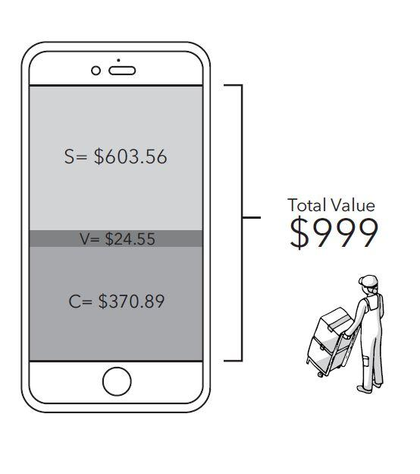

As we will explore in our next classes, it is not about the capitalist being good or bad, not a moral analysis but a structural analysis of the forces at play under capitalism: capitalists have a tendency to increase the rate of exploitation because they also depend on the market to be able to sell their commodities and thus make a profit. Capitalists are under the pressure of real competition: if one of them does not make a profit, then someone else will! [we will explore this in our next class]

There are two main ways to increase the rate of exploitation:

[Q2 of this week’s discussion: What is absolute and what is relative surplus-value? Provide some historical examples for each using the sources at your disposal (iPhone case, Amazon article, Taylorism, etc.) and explain how they help increase the rate of exploitation].

- Absolute Surplus Value
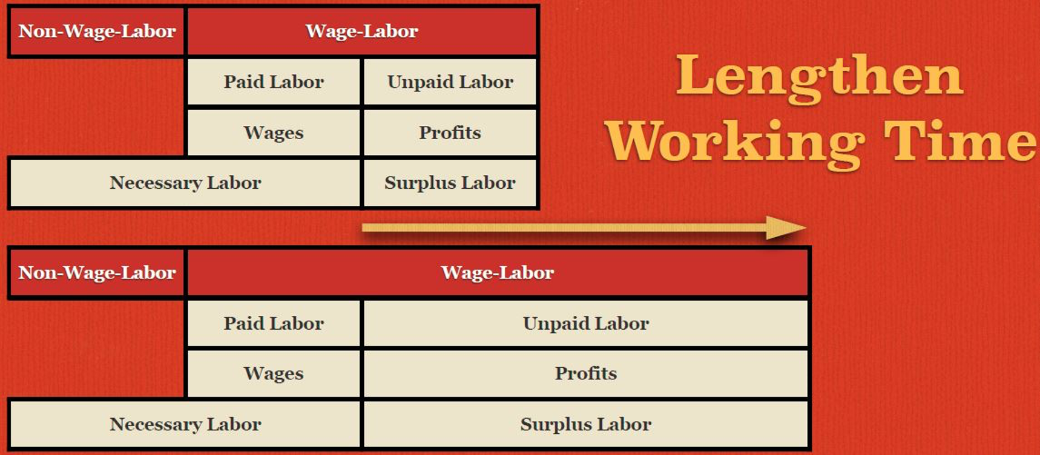

Capitalists have the tendency to increase Absolute surplus value: they prolong the working day: so that the total surplus value created in a day goes up...

“The prolongation of the working day beyond the point at which the labourer would have produced just an equivalent for the value of his labour-power, and the appropriation of that surplus labour by capital, this is production of absolute surplus-value” (Capital, ch 16 p. 160)
Example: from an 8-hour working day: (S) 4 hours / (V) 4 hours = 100 percent, to a 12 hour working day: (S) 8 hours / (V) 4 hours = 200 percent.
- It is to be kept in mind that avoiding too long of a day's work becomes a constraint for the capitalist: capitalists cannot work their workers to death as the pool of available labor is depleted [this is a typical contradiction of capitalism: what is good for one employer--increasing the day’s work---is not good for the whole capitalist class (or for the possibility of capital accumulation in general) given that if they all die of overwork, there won’t be sufficient workers to hire]
- Workers’ struggles throughout the 1800s and 1900s were centered on the battle for reducing the working day. Governments changed the laws because of pressure from below (strikes, mobilization) See the Historical TV series The Mill (2013)
- For example, the 8-hour working day law was achieved after WWI; now we again work many more hours--think about the gig economy: you have very flexible working hours, and you work at any time of day, even at hours that before were considered non-working hours.
Worker’s resistance is a threat to capitalists...thus they need to find a less explicit (thus politically less contestable) way to increase exploitation!
2) Relative Surplus Value
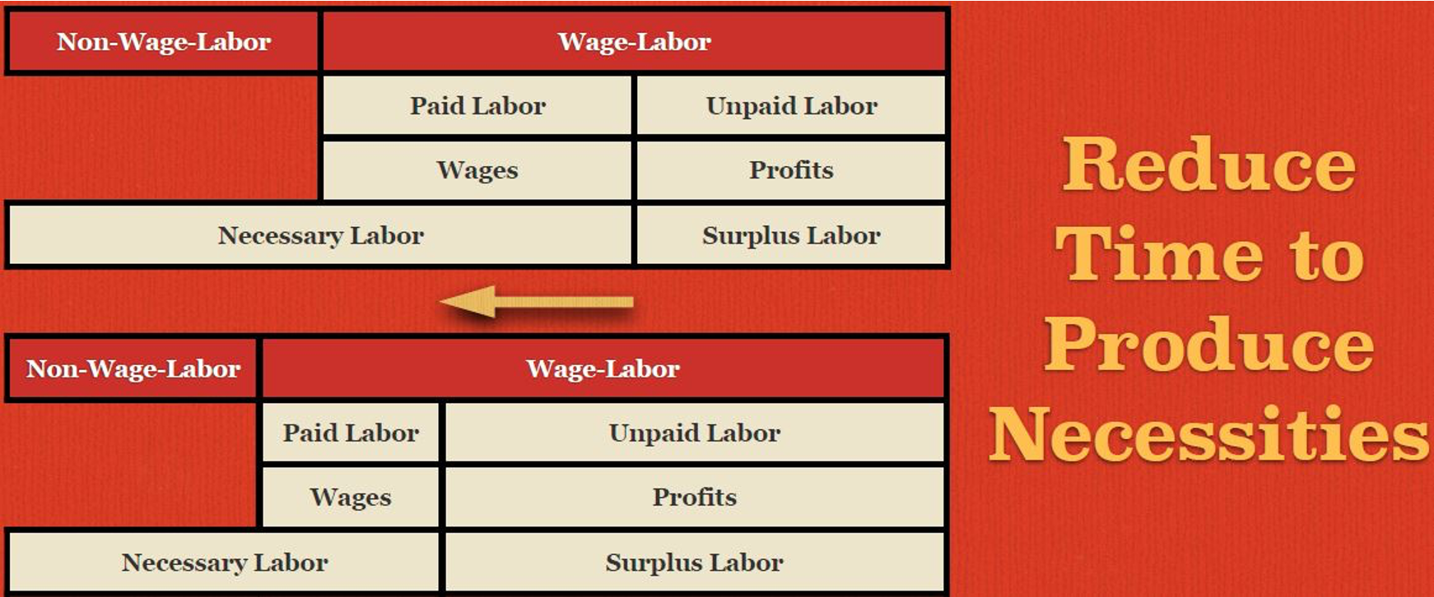

The paid labor portion of the working day is reduced because the amount of labor-time that is necessary for a worker to pay back her wage will be reduced. In this case, the length of the working day doesn’t increase, but how much surplus value is produced does increase.

This means that you alter the ratio of value produced during the course of the day so that less of it goes toward repaying the value of wages and more of it goes over to the capitalist in the form of surplus value.
From an 8-hour working day: (S) 4 hours / (V) 4 hours = 100 percent; Now, from the same 8-hour working day, you take less time to pay back your daily wages: (S) 5 hours / (V) 3 hours = 166 percent.
How does relative surplus value increase?
1) Increase the productivity of labor
2) Increase the intensity of labor

[Note that an increase in the intensity of labor is different than an increase in labor productivity: an increase in intensity means that with the same tools, you are working faster (more labor exerted in one hour). On the other hand, an increase in productivity means that you produce more, not because you are expending more muscle energy but because you are working with a better machine. As we shall see, technological innovation is a fundamental feature of capitalism because the tendency is for capitalists to lower the prices of goods so as to beat their competitors. The increases in intensity and productivity historically go together as shown in the 1936 film Charlie Chaplin Modern Times that you had as homework.

[Relate to question 3. How does the film Modern Times represent the phenomenon of exploitation?]

Examples of increases in relative surplus value vary according to the historical moment. The most emblematic increase in relative surplus value came at the end of the 1890s with the introduction of Taylorism (see Hadas Thier pp. 102-104) and the principle of scientific management that embodies both these strategies.

Here mechanization and the breaking down of work into simpler tasks produces the deskilling of workers (who thus can get paid less and become more easily substitutable with others). At the same time, it increases both productivity and intensity.

“Every task was studied, broken down into individual components, and timed in order to determine the minimal intervals required to accomplish each. The timing and methods of work could then be standardized—whether that be through speeding up the conveyor belt in an auto plant or using keystroke counters to mechanize office jobs.” (Thier, p.102)

“Since then, the twenty-first century version of the same is often referred to as “lean production”: speedups, de-skilling, use of temporary and contract workers, greater management flexibility on hours and tasks, etc. These processes have resulted in “the greatest work intensification in US history,” according to Kim Moody, “far surpassing the now quaint norms of Taylorism.” (Thier, p.98)

Another important strategy in the workplace is the full supervision and monitoring of the workforce to make sure that intensity is kept high (think about the Amazon strikes to get more time for the bathroom break or the movie Modern Times). Associate the Amazon article in the Guardian here:

“I was a picker and we were expected to always pick 400 units within the hour in seven seconds of each item we picked,” said Espinoza. “I couldn’t handle it. I’m a human being, not a robot.”...“You’re being tracked by a computer the entire time you’re there. You don’t get reported or written up by managers. You get written up by an algorithm,” said Geller. “You’re keenly aware there is an algorithm keeping track of you, making sure you keep going as fast as you can, because if there is too much time lapsed between items, the computer will know this, will write you up, and you will get fired.”

Injuries and death in workplaces are, in fact, quite common. Safety concerns are not part of the logic of capital accumulation…

III. Exploitation in the 20th and 21st Century

During the so-called “golden age” of capitalism (1945-1975), productivity was growing faster than wages. This meant that higher wages were compatible with higher profits since wages were still growing less than productivity. Since the late 70s, however, we have seen an increase in productivity with stagnating wages. This means that the rates of exploitation have gone up!
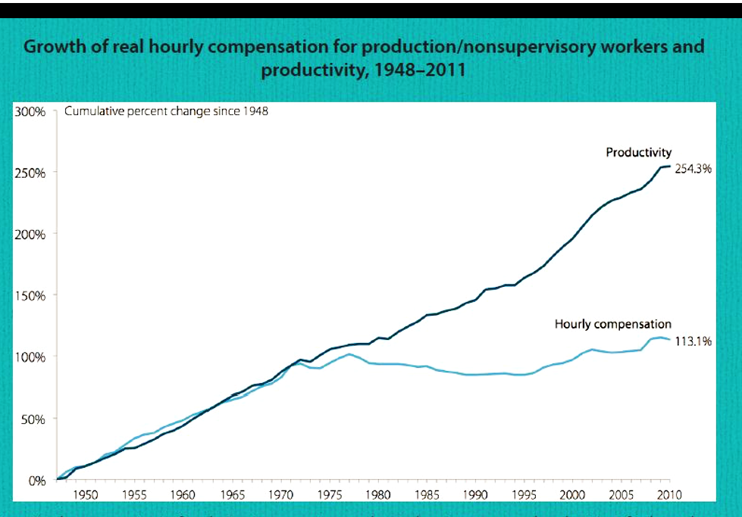

The trend of increasing the intensity of labor is worsened by the GIG ECONOMY that INTENSIFIES the EXTRACTION OF SURPLUS VALUE.

Today’s gig economy is about getting paid (or getting the jobs) only if you perform specific tasks at a certain speed. It's even more subtle because it appears as if it's your choice to work longer, giving fake agency to workers.

Example: Sales role at a company: 60 phone calls in one hour with five sign ups for extra commission. $8 base pay.

Or delivery men at Amazon who get more delivery assignments from the app if they work faster (all calculated through an algorithm).

Business Insider Article: “Some drivers who deliver packages for Amazon told Business Insider they speed, blow stop signs, and skip meal and bathroom breaks to complete deliveries on time…In interviews with Business Insider, nine current or recently employed drivers of Amazon-affiliated courier companies complained about workers urinating in bottles, bags, or outside to save time on the road”
On the gig economy see NPR podcast “the uncertain hour” (you are no longer an employee; you are an independent contractor now: more flexibility, more risk. See the story of Janpro--and the janitor who makes 5 dollars an hour. Or the case of Uber: independent contractors who make so little that they are homeless and without any form of benefit.

Since the late 1970s in the USA, we have seen a decreasing number of Americans employed in the manufacturing sector (where you can, in fact, increase productivity with technological innovation and rising mechanization). Today, the majority of jobs in the USA are jobs in the service sector, which accounts for 79% of Americans as of 2019. (restaurants, stores, etc.). In the service sector, the key to increasing the rate of exploitation is not to increase productivity but to suppress wages (even below subsistence): companies like Uber thrive thanks to cheap labor.

Note that the median American male worker today actually earns less in real terms than what he did in 1973. Since that year, structural inequality has robbed American workers of $2.5 trillion each year, money that flowed directly into the hands of the few.

Thus, the value of the commodity labor power has reached unprecedented lows. To the point that, as of 2023, 62% of Americans live pay check to paycheck meaning one missed paycheck away from poverty.

The phenomenon of the working poor is expanding:

It was estimated in 2022 that 100 million Americans are living at or below 200 percent of the poverty level, of which many are children and seniors. However, over 12 million of them are full-time workers between the ages of 25 and 64. Of these poor full-time workers the majority -- 56 percent -- are workers of color. Working poverty has increased dramatically over the last three decades, growing from less than 7 million in 1980 to today’s 12.4 million.

[Notwithstanding the level of pay, under capitalism, all workers live the phenomenon of alienation --- you are alienated (separated) from the product of your labor but also from your very working activity (you are separated from yourself during your workday and thus feel dissatisfied. You feel alive only outside of your workplace. You are also alienated from nature and from others, so you pit yourself against your peers].

Related to this, see the article on the Indian delivery man:

“According to popular job search sites, food delivery companies say they'll pay an employee around $250 a month. That may put them in the top 20 percent earners in the country but it's barely enough to live in cities (where most food delivery apps operate) as the cost of living is also higher. In media interviews, delivery persons have described how they have to work long hours, since they are typically paid per delivery — roughly $1 per order”.

Main takeaways of today’s class:

In this class, we have uncovered the basis for profits (the driver of capitalism); we’ve discussed the specificities of capitalist exploitation and the main ways in which the rate of exploitation is increased (absolute and relative surplus value) and how these increases were visible throughout the last 200 years of the history of capitalism.

